What are the Benefits of TestNG?
There are a number of benefits but from Selenium perspective, major advantages of TestNG are :
- It gives the ability to produce HTML Reports of execution
- Annotations made testers life easy
- Test cases can be Grouped & Prioritized more easily
- Parallel testing is possible
- Generates Logs
- Data Parameterization is possible
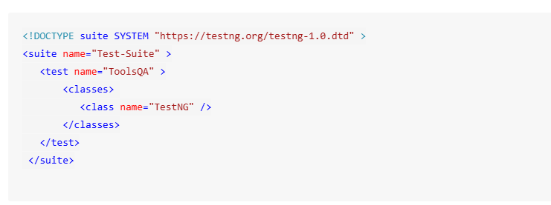
X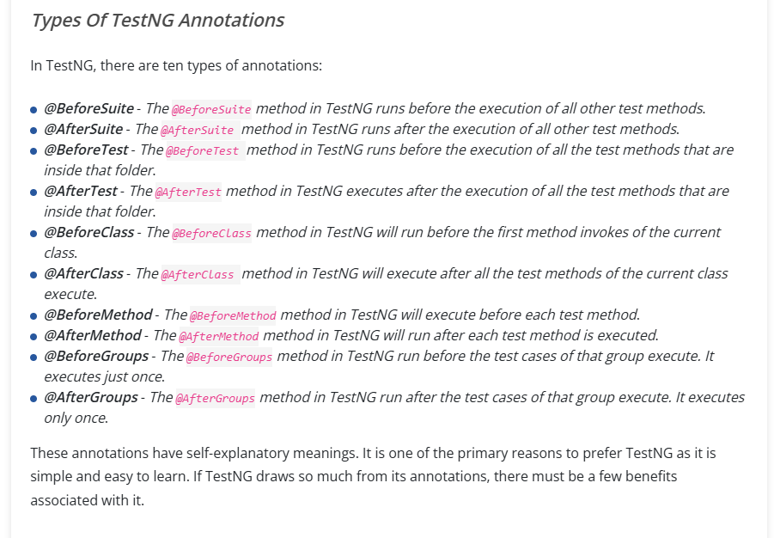
- @BeforeSuite
- @BeforeTest
- @BeforeClass
- @BeforeMethod
- @Test
- @AfterMethod
- @AfterClass
- @AfterTest
- @AfterSuite

TestNG Annotations are special markers in Java (starting with @) that control the flow and structure of test execution in TestNG. They tell the framework when to execute setup, teardown, and test methods making automation scripts cleaner, modular, and easier to maintain.
What Are TestNG Annotations?
TestNG annotations define the test lifecycle from initialization to cleanup, without relying on XML configuration alone. Each annotation performs a specific role, like setting up before tests (@BeforeMethod) or running actions after all tests (@AfterSuite).
They also manage dependencies, groups, data inputs, and test order, helping testers build flexible and reusable automation frameworks.
Core TestNG Annotations and Their Roles
- Test Execution Control:
  - @Test: Marks a method as a test case.
  - @BeforeSuite / @AfterSuite: Run once before and after the entire suite.
  - @BeforeTest / @AfterTest: Run before and after <test> blocks in testng.xml.
  - @BeforeClass / @AfterClass: Execute once per test class.
  - @BeforeMethod / @AfterMethod: Run before and after each test method.
- Group and Dependency Management:
  - @BeforeGroups / @AfterGroups: Trigger before or after specific test groups.
  - dependsOnMethods / dependsOnGroups:Ensure tests run only after dependencies pass.
- Data and Parameter Handling:
  - @DataProvider: Supplies multiple data sets to a single test.
  - @Parameters: Pass values from testng.xml into test methods.
- Utility Annotations:
  - @Listeners: Attach custom listeners for logging or reporting.
  - @Factory: Execute parameterized test classes dynamically.
  - @Ignore: Skip a test temporarily without deleting it.
Execution Order in TestNG (Most Asked in Interviews)
The standard execution hierarchy is:
@BeforeSuite → @BeforeTest → @BeforeClass → @BeforeMethod → @Test → @AfterMethod → @AfterClass → @AfterTest → @AfterSuite
Important Annotation Attributes You Should Know
- priority – Defines the order in which test methods run.
- enabled – Set false to skip a test without removing it.
- timeOut – Fails a test if it exceeds the given duration.
- invocationCount – Runs a test method multiple times automatically.
- expectedExceptions – Passes a test if a specific exception is thrown.
These attributes help fine-tune test behavior for better reliability and speed.
Best Practices for Using TestNG Annotations
- Use @BeforeMethod and @AfterMethod for setup/cleanup at the test level.
- Manage test data using @DataProvider instead of hardcoding inputs.
- Use @Listeners to integrate reporting or screenshot capture in Selenium tests.
- Keep test methods independent, avoid cross-test dependencies unless needed.
- Control test flow with priority and dependsOnMethods instead of thread sleeps.
An annotation is a tag that provides additional information about the class or method. It is represented by ‘@’ prefix. TestNG use these annotations to help in making a robust framework. Let us have a look at these annotations of TestNG for Selenium.
==
@Test
The most important TestNG annotations framework where the main business logic resides. All functionalities to be automated are kept inside the @Test annotation method. It has various attributes based on which the method can be reformed and executed.
Example of a code snippet below validating the url :
1  2  3  4  5  6  7  8 | @Test  public void testCurrentUrl() throws InterruptedException  {  driver.findElement(By.xpath("//*[@id='app']/header/aside/ul/li[4]/a")).click();  String currentUrl= driver.getCurrentUrl();  assertEquals(current_url, "https://automation.lambdatest.com/timeline/?viewType=build&page=1", "url did not matched");  }
@BeforeTest
This annotation is run before your first @Test TestNG Annotations method in your class. You can use this annotation in TestNG for Selenium to setup your browser profile preferences, for example auto opening your browser in maximize mode, setting up your own customized profile for your browser etc.
Below is the code snippet for BeforeTest method ensuring the browser opens in maximize mode:
1  2  3  4  5  6  7 | @BeforeTest  public void profileSetup()  {  driver.manage().window().maximize();  }

@AfterTest
This TestNG Annotations runs after all your test methods belonging to your class have run. This is a useful annotation which comes handy in terms of reporting your automation results to your stakeholders. You can use this annotation to generate report of your tests and share it to your stakeholders via email.
Example of the code snippet below:
1  2  3  4  5 | @AfterTest  public void reportReady()  {  System.out.println("Report is ready to be shared, with screenshots of tests");  }

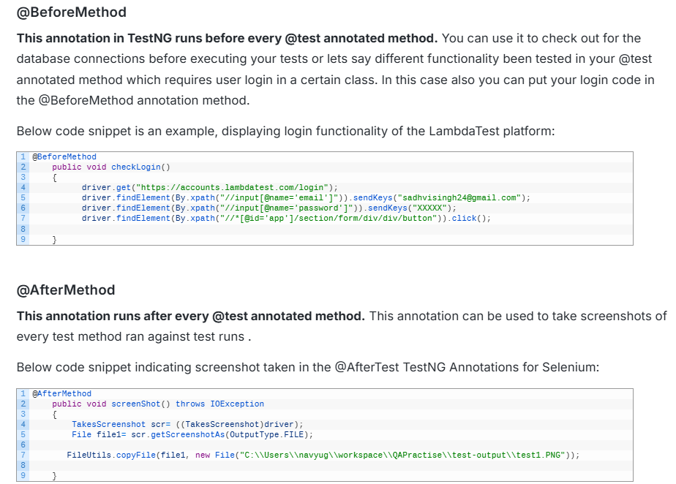
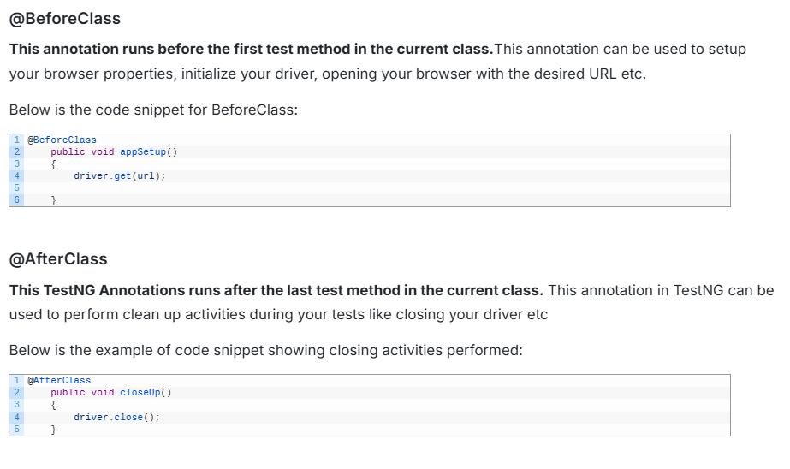
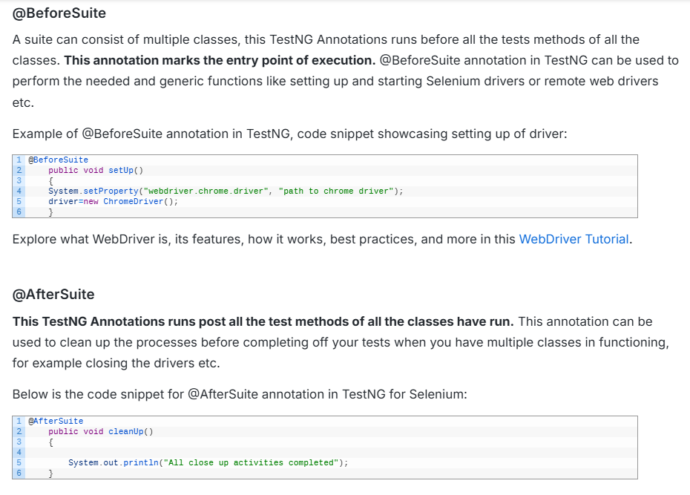
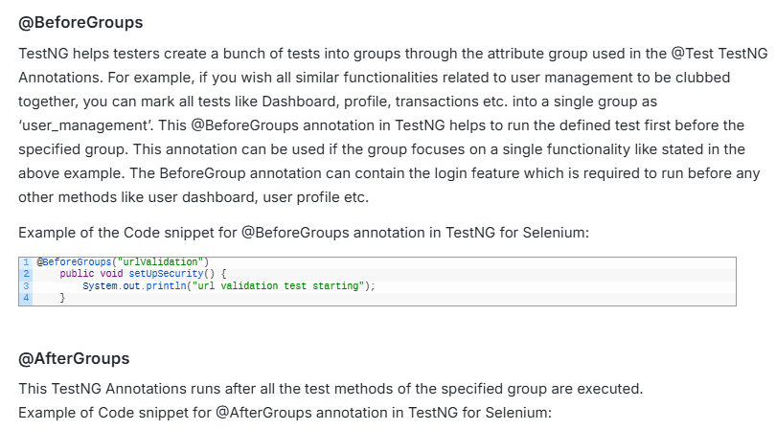
Program ======
@AfterGroups("urlValidation")
public void tearDownSecurity() {
System.out.println("url validation test finished");
}

The below code displays an example of all annotations used along with TestNG report respectively:

import static org.testng.Assert.assertEquals;

import java.io.File;
import java.io.IOException;
import java.util.concurrent.TimeUnit;

import org.apache.commons.io.FileUtils;
import org.openqa.selenium.By;
import org.openqa.selenium.OutputType;
import org.openqa.selenium.TakesScreenshot;
import org.openqa.selenium.WebDriver;
import org.openqa.selenium.chrome.ChromeDriver;
import org.testng.annotations.AfterClass;
import org.testng.annotations.AfterGroups;
import org.testng.annotations.AfterMethod;
import org.testng.annotations.AfterSuite;
import org.testng.annotations.AfterTest;
import org.testng.annotations.BeforeClass;
import org.testng.annotations.BeforeGroups;
import org.testng.annotations.BeforeMethod;
import org.testng.annotations.BeforeSuite;
import org.testng.annotations.BeforeTest;
import org.testng.annotations.Test;

public class AnnotationsTestNG {

public WebDriver driver;
public String url="https://www.lambdatest.com/";

@BeforeSuite
public void setUp()
{
System.setProperty("webdriver.chrome.driver", "C:\\Users\\navyug\\workspace\\QAPractise\\src\\ChromeDriver\\chromedriver.exe");
driver=new ChromeDriver();
driver.manage().timeouts().implicitlyWait(20, TimeUnit.SECONDS);
System.out.println("The setup process is completed");
}

@BeforeTest
public void profileSetup()
{
driver.manage().window().maximize();
System.out.println("The profile setup process is completed");

}

@BeforeClass
public void appSetup()
{
driver.get(url);
System.out.println("The app setup process is completed");
}

@BeforeMethod
public void checkLogin()
{
driver.get("https://accounts.lambdatest.com/login");
driver.findElement(By.xpath("//input[@name='email']")).sendKeys("sadhvisingh24@gmail.com");
driver.findElement(By.xpath("//input[@name='password']")).sendKeys("activa9049");
driver.findElement(By.xpath("//*[@id='app']/section/form/div/div/button")).click();
System.out.println("The login process on lamdatest is completed");
}

@Test(groups="urlValidation")
public void testCurrentUrl() throws InterruptedException
{
driver.findElement(By.xpath("//*[@id='app']/header/aside/ul/li[4]/a")).click();
Thread.sleep(6000);
String currentUrl= driver.getCurrentUrl();
assertEquals(currentUrl, "https://automation.lambdatest.com/timeline/?viewType=build&page=1", "url did not matched");
System.out.println("The url validation test is completed");
}

@AfterMethod
public void screenShot() throws IOException
{
TakesScreenshot scr= ((TakesScreenshot)driver);
File file1= scr.getScreenshotAs(OutputType.FILE);

FileUtils.copyFile(file1, new File("C:\\Users\\navyug\\workspace\\QAPractise\\test-output\\test1.PNG"));
System.out.println("Screenshot of the test is taken");
}

@AfterClass
public void closeUp()
{
driver.close();
System.out.println("The close_up process is completed");
}

@AfterTest
public void reportReady()
{
System.out.println("Report is ready to be shared, with screenshots of tests");
}

@AfterSuite
public void cleanUp()
{

System.out.println("All close up activities completed");
}

@BeforeGroups("urlValidation")
public void setUpSecurity() {
System.out.println("url validation test starting");
}

@AfterGroups("urlValidation")
public void tearDownSecurity() {
System.out.println("url validation test finished");
}

}
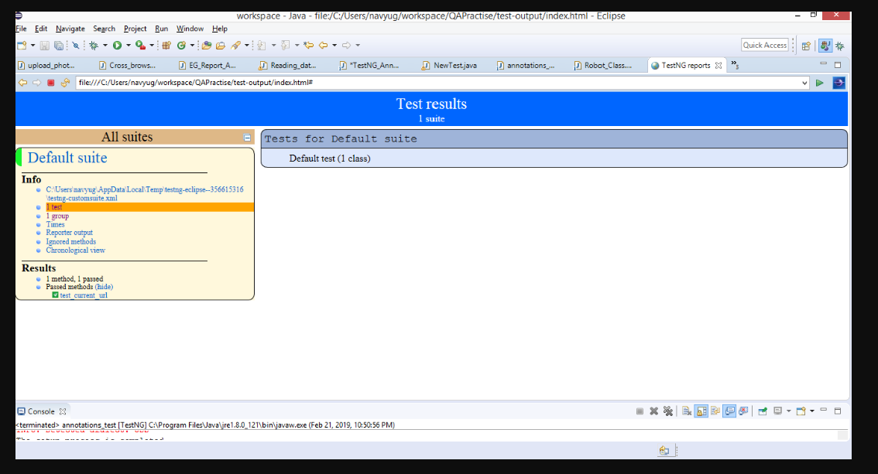
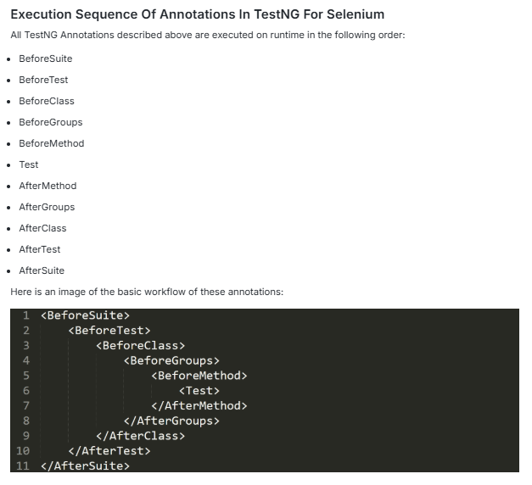

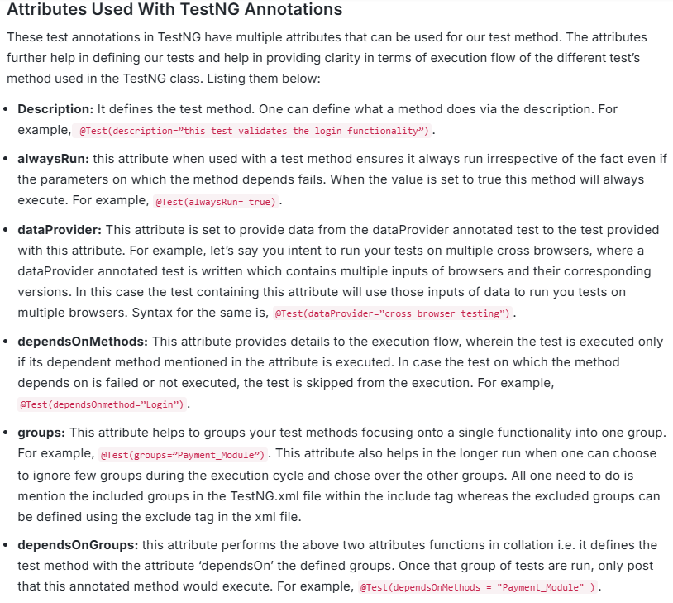
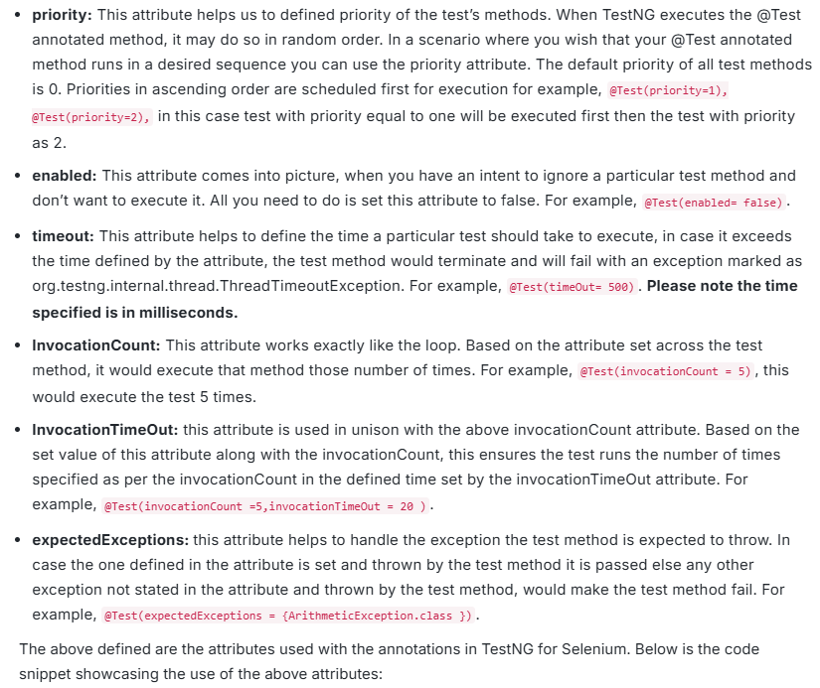
import static org.testng.Assert.assertEquals;
import java.io.File;
import java.io.IOException;
import java.util.concurrent.TimeUnit;
import org.apache.commons.io.FileUtils;
import org.openqa.selenium.By;
import org.openqa.selenium.OutputType;
import org.openqa.selenium.TakesScreenshot;
import org.openqa.selenium.WebDriver;
import org.openqa.selenium.WebElement;
import org.openqa.selenium.chrome.ChromeDriver;
import org.testng.annotations.AfterClass;
import org.testng.annotations.AfterGroups;
import org.testng.annotations.AfterMethod;
import org.testng.annotations.AfterSuite;
import org.testng.annotations.AfterTest;
import org.testng.annotations.BeforeClass;
import org.testng.annotations.BeforeGroups;
import org.testng.annotations.BeforeMethod;
import org.testng.annotations.BeforeSuite;
import org.testng.annotations.BeforeTest;
import org.testng.annotations.Test;

public class AnnotationsTest {

public WebDriver driver;
public String url="https://www.lambdatest.com/";

@BeforeSuite
public void setUp()
{
System.setProperty("webdriver.chrome.driver", "C:\\Users\\navyug\\workspace\\QAPractise\\src\\ChromeDriver\\chromedriver.exe");
driver=new ChromeDriver();
System.out.println("The setup process is completed");
}

@BeforeTest
public void profileSetup()
{
driver.manage().window().maximize();
System.out.println("The profile setup process is completed");

}

@BeforeClass
public void appSetup()
{
driver.get(url);
System.out.println("The app setup process is completed");
}

@Test(priority=2)
public void checkLogin()
{
driver.get("https://accounts.lambdatest.com/login");
driver.findElement(By.xpath("//input[@name='email']")).sendKeys("sadhvisingh24@gmail.com");
driver.findElement(By.xpath("//input[@name='password']")).sendKeys("xxxxx");
driver.findElement(By.xpath("//*[@id='app']/section/form/div/div/button")).click();
System.out.println("The login process on lamdatest is completed");
}

@Test(priority=0 ,description= "this test validates the sign-up test")
public void signUp() throws InterruptedException
{
WebElement link= driver.findElement(By.xpath("//a[text()='Free Sign Up']"));
link.click();
WebElement organization=driver.findElement(By.xpath("//input[@name='organization_name']"));
organization.sendKeys("LambdaTest");
WebElement firstName=driver.findElement(By.xpath("//input[@name='name']"));
firstName.sendKeys("Test");
WebElement email=driver.findElement(By.xpath("//input[@name='email']"));
email.sendKeys("User622@gmail.com");
WebElement password=driver.findElement(By.xpath("//input[@name='password']"));
password.sendKeys("TestUser123");
WebElement phoneNumber=driver.findElement(By.xpath("//input[@name='phone']"));
phoneNumber.sendKeys("9412262090");
WebElement termsOfService=driver.findElement(By.xpath("//input[@name='terms_of_service']"));
termsOfService.click();
WebElement button=driver.findElement(By.xpath("//button[text()='Signup']"));
button.click();

}

@Test(priority=3, alwaysRun= true, dependsOnMethods="check_login", description="this test validates the URL post logging in" , groups="url_validation")
public void testCurrentUrl() throws InterruptedException
{
driver.findElement(By.xpath("//*[@id='app']/header/aside/ul/li[4]/a")).click();
String currentUrl= driver.getCurrentUrl();
assertEquals(current_url, "https://automation.lambdatest.com/timeline/?viewType=build&page=1", "url did not matched");
System.out.println("The url validation test is completed");
}

@Test(priority=1, description = "this test validates the logout functionality" ,timeOut= 25000)
public void logout() throws InterruptedException
{
Thread.sleep(6500);
driver.findElement(By.xpath("//*[@id='userName']")).click();
driver.findElement(By.xpath("//*[@id='navbarSupportedContent']/ul[2]/li/div/a[5]")).click();
}

@Test(enabled=false)
public void skipMethod()
{
System.out.println("this method will be skipped from the test run using the attribute enabled=false");
}

@Test(priority=6,invocationCount =5,invocationTimeOut = 20)
public void invocationcountShowCaseMethod()
{
System.out.println("this method will be executed by 5 times");
}

@AfterMethod()
public void screenshot() throws IOException
{
TakesScreenshot scr= ((TakesScreenshot)driver);
File file1= scr.getScreenshotAs(OutputType.FILE);

FileUtils.copyFile(file1, new File("C:\\Users\\navyug\\workspace\\QAPractise\\test-output\\test1.PNG"));
System.out.println("Screenshot of the test is taken");
}

@AfterClass
public void closeUp()
{
driver.close();
System.out.println("The close_up process is completed");
}

@AfterTest
public void reportReady()
{
System.out.println("Report is ready to be shared, with screenshots of tests");
}

@AfterSuite
public void cleanUp()
{

System.out.println("All close up activities completed");
}

@BeforeGroups("urlValidation")
public void setUpSecurity() {
System.out.println("url validation test starting");
}

@AfterGroups("urlValidation")
public void tearDownSecurity() {
System.out.println("url validation test finished");
}

}
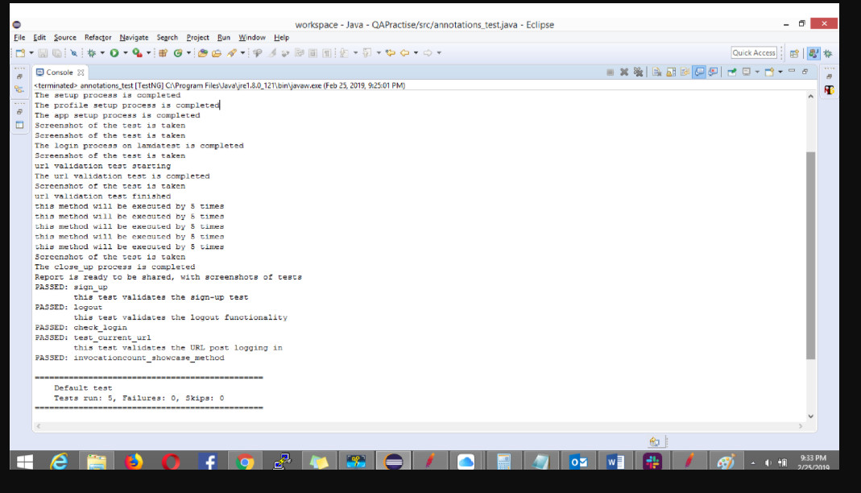

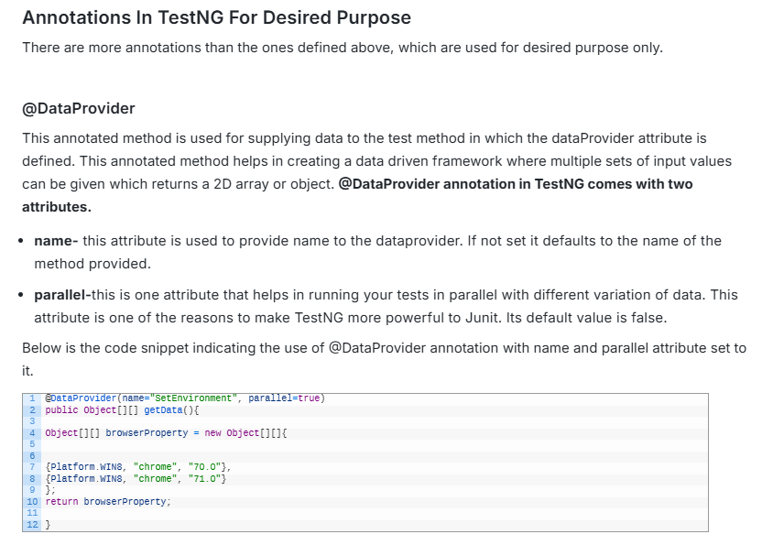
Factory
This annotation helps to run multiple test classes through a single test class. It basically defines and create tests dynamically.
The below code snippet indicates the use of @Factory annotation that helps calls the test method class.
package ChromeDriver;

import org.testng.annotations.Test;

public class FactorySimplyTest1 {

@Test
public void testMethod1() {
System.out.println("This is to test for method 1 for Factor Annotation");

}}

package ChromeDriver;

import org.testng.annotations.Test;

public class FactorySimpleTest2 {

@Test
public void testMethod2() {
System.out.println("This is to test for method 2 for Factor Annotation");

}
}

package ChromeDriver;

import org.testng.annotations.Factory;
import org.testng.annotations.Test;

public class FactoryAnnotation {

@Factory()
@Test
public Object[] getTestFactoryMethod() {
Object[] factoryTest = new Object[2];
factoryTest[0] = new FactorySimplyTest1();
factoryTest[1] = new FactorySimpleTest2();
return factoryTest;
}

}

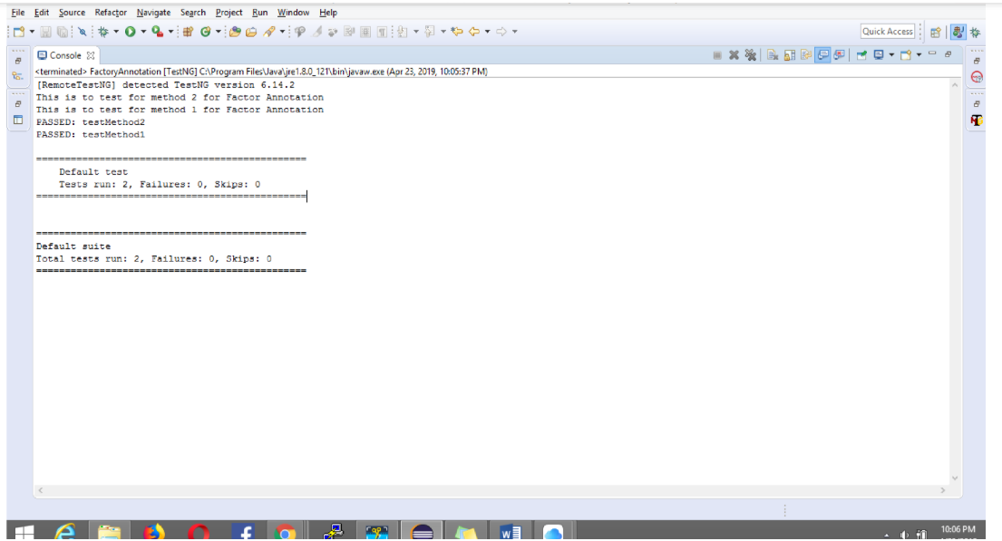
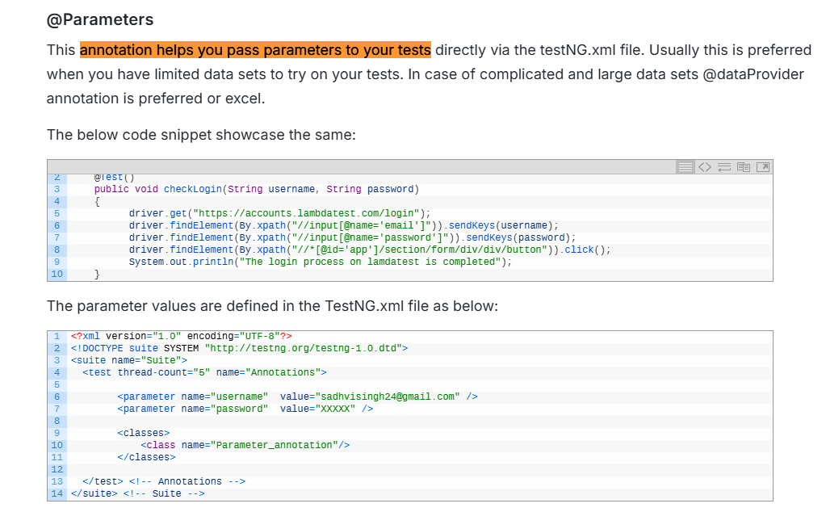
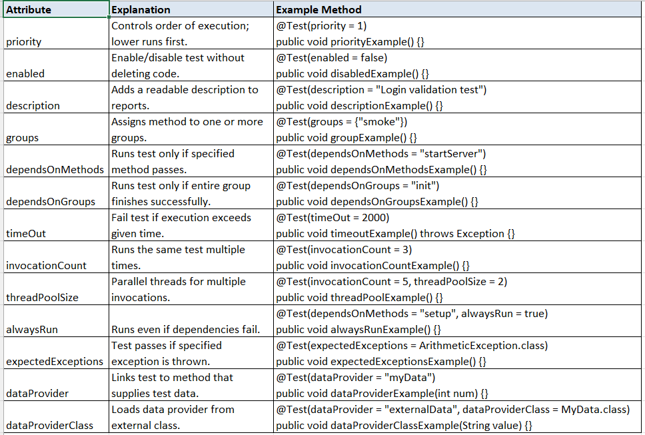
WHY do we need retries?
Because automation tests can fail sometimes due to:
- Slow networks
- Element not clickable yet
- API delay
- Browser hiccups
- Temporary server lag
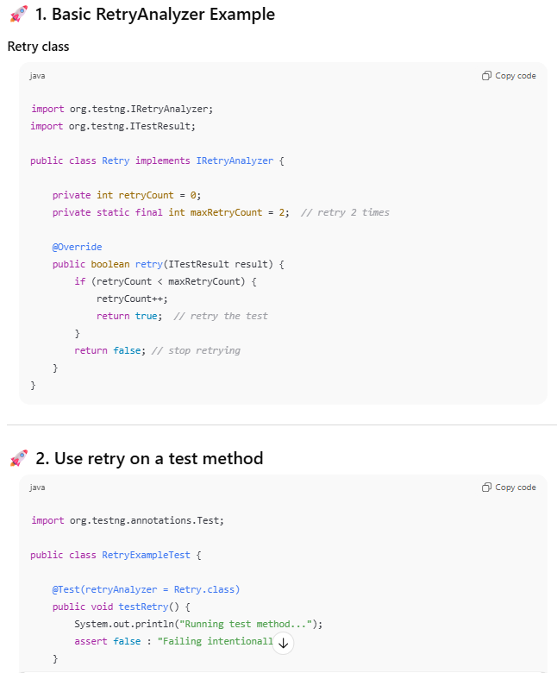
What happens?
- Test fails 1st time → retry
- Fails again → retry
- Fails 3rd time → stop
- Test marked as FAILED (after retries exhausted)

📘 Test Execution Timeline
Run 1 → FAIL → Retrying...
Run 2 → FAIL → Retrying...
Run 3 → FAIL → STOP → Mark failed

⭐ ADVANCED LEVEL: Attach Retry Automatically Without Editing Each Test
If you don’t want to add:
@Test(retryAnalyzer = Retry.class)
on every test method…
TestNG provides IAnnotationTransformer to add retry automatically.

🚀 3. Auto-apply retry to all tests (best practice)
import org.testng.IAnnotationTransformer;
import org.testng.annotations.ITestAnnotation;
import java.lang.reflect.Constructor;
import java.lang.reflect.Method;

public class RetryTransformer implements IAnnotationTransformer {

@Override
public void transform(ITestAnnotation annotation, Class testClass,
Constructor testConstructor, Method testMethod) {
annotation.setRetryAnalyzer(Retry.class);
}
}

✔ Enable the transformer in testng.xml
<listeners>
<listener class-name="yourpackage.RetryTransformer"/>
</listeners>
Now ANY @Test automatically gets retry behavior 🎉
(no extra code inside tests)

⭐ PRO TIP: Logging retry attempts
Add this inside retry method:
System.out.println("Retrying " + result.getName() + " again, count: " + retryCount);

⭐ PRO TIP: Skip retry for some groups
Inside retry():
if (result.getMethod().getGroups().length > 0 &&
Arrays.asList(result.getMethod().getGroups()).contains("no-retry")) {
return false; // never retry this group
}

📚 Where retries help MOST
- Selenium UI tests
- API tests with unstable servers
- Slow application load
- Cross-browser tests
- Cloud providers like BrowserStack / SauceLabs
Retries should not hide real failures, but should reduce false alarms.

🎓 ELI12 Summary
Feature | Meaning
IRetryAnalyzer | Interface to retry failed tests
retry() | returns TRUE to retry the test
retryCount | counts attempts
maxRetryCount | limit retries
retryAnalyzer = class | adds retry to specific test
AnnotationTransformer | adds retry to ALL tests automatically

